This article has been accepted for inclusion in a future issue of this journal. Content is final as presented, with the exception of pagination.

IEEE SYSTEMS JOURNAL | 1

Location-Based Key Management Strong Against Insider Threats in Wireless Sensor Networks

Jaewoo Choi, Jihyun Bang, LeeHyung Kim, Mirim Ahn, and Taekyoung Kwon, Member, IEEE

Abstract—To achieve secure communications in wireless sen-sor networks (WSNs), sensor nodes (SNs) must establish secret shared keys with neighboring nodes. Moreover, those keys must be updated by defeating the insider threats of corrupted nodes. In this paper, we propose a location-based key management scheme for WSNs, with special considerations of insider threats. After reviewing existing location-based key management schemes and studying their advantages and disadvantages, we selected location-dependent key management (LDK) as a suitable scheme for our study. To solve a communication interference problem in LDK and similar methods, we have devised a new key revision process that incorporates grid-based location information. We also propose a key establishment process using grid information. Furthermore, we construct key update and revocation processes to effectively resist inside attackers. For analysis, we conducted a rigorous simulation and confirmed that our method can increase connec-tivity while decreasing the compromise ratio when the minimum number of common keys required for key establishment is high. When there was a corrupted node leveraging insider threats, it was also possible to effectively rekey every SN except for the corrupted node using our method. Finally, the hexagonal deployment of anchor nodes could reduce network costs.

Index Terms—Insider threats, key revision process, location-based key management, packet drop attack, wireless sensor network (WSN).

- INTRODUCTION

A WIRELESS sensor network (WSN) refers to a group of spatially scattered sensors for monitoring and recording the physical conditions of an environment and for sending

the collected data. A WSN consists of hundreds to thousands of sensor nodes (SNs) performing wireless communication. WSNs not only measure environmental conditions such as temperature and sound but also gather sensitive data pertaining to people [1]. Therefore, to prevent privacy issues, all commu-nications should be carried out securely [2].

According to Gartner [26], the Internet of Things (IoT) will connect 26 billion devices by 2020 and will have a high

Manuscript received November 30, 2014; revised February 18, 2015; accepted March 24, 2015. This work was supported in part by the Korean Agency for Defense Development through the project named “A Research on Dynamic Networking and Security for Wireless Sensor Networks and Mobile Networks” and in part by the Korean Ministry of Science, ICT and Future Planning (MSIP) through the Information Technology Research Center Support Program under Grant IITP-2015-H8501-15-1008, which is supervised by the Institute for Information and Communications Technology Promotion. (Corresponding author: T. Kwon.)

J. Choi, J. Bang, and T. Kwon are with the Graduate School of Informa-tion, Yonsei University, Seoul 120-749, Korea (e-mail: jw.choi@yonsei.ac.kr; jhbang@yonsei.ac.kr; taekyoung@yonsei.ac.kr).

L. Kim and M. Ahn are with the Agency for Defense Development, Seoul 350-600, Korea (e-mail: ihkim@add.re.kr; mahn@add.re.kr).
Digital Object Identifier 10.1109/JSYST.2015.2422736

economic value. WSNs are the foundation technique of the IoT, and for this reason, technical research in this area is being actively pursued. In particular, research applied to various fields such as military, medicine, industry, and traffic proceed continuously [3]. Moreover, security is an important area in the study of WSNs because it uses actual data [4]. Insider threats are also a critical security issue in WSNs because general security techniques such as authentication and authorization cannot detect insider attackers. This is a serious threat for many applications such as military surveillance systems that monitor battlefields and other critical infrastructures.

The key management technique originated by Eschenauer and Gligor [5] and subsequent studies thereof are a very active area of research in sensor networks. This paper is divided into two parts, i.e., symmetric key based and public key based. More-over, there are various other methods of key management, such as pairwise key management, predistributed random key man-agement, and location-based key management. Because of the hardware restrictions of SNs, the main objectives of key man-agement for WSNs are efficiency, scalability, and heterogeneity.

In WSNs, location information is important for the gener-ation of shared keys and is highly applicable. Thus, location-based key management is a core part of the research into WSN key management. Grid-based key management in location-based key management dictates that an SN should be located in an assigned grid. This feature can be a weak point according to the applied environment. For instance, when sensor networks are used for enemy detection in a military zone, it is difficult to locate SNs in an assigned grid. Anjum proposed a scheme that is only dependent on the location of SNs without any specific knowledge of how they are deployed [6]. However, Anjum’s scheme only considered outsider threats, and research into insider threats to key management in a WSN is insufficient. Hence, based on Anjum’s scheme, we have developed a key management technique that considers insider threats to WSNs.

The rest of this paper is structured as follows. We look at preliminary steps in Section II. We describe our scheme based on location-dependent key management (LDK) in Section III. Security analysis is described in Section IV, and the simulation is described in Section V. In Section VI, we look at related work, and finally, we present our conclusion in Section VII.

- PRELIMINARIES

In this section, we offer background knowledge before pre-senting our scheme. We review LDK, which is the foundational technique of our scheme; network models; and threat models. We also briefly explain the symbols used and their descriptions.

1932-8184 © 2015 IEEE. Personal use is permitted, but republication/redistribution requires IEEE permission.
See http://www.ieee.org/publications_standards/publications/rights/index.html for more information.

This article has been accepted for inclusion in a future issue of this journal. Content is final as presented, with the exception of pagination.

2 IEEE SYSTEMS JOURNAL

TABLE I
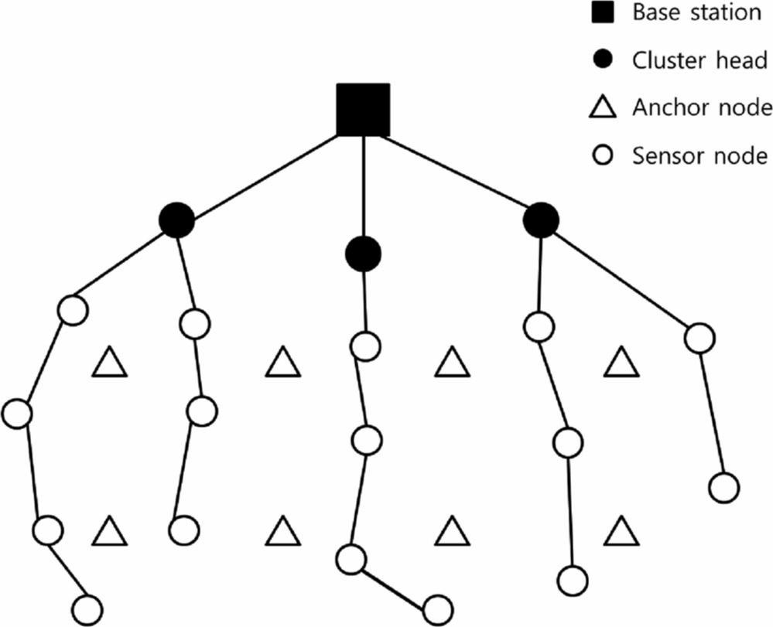
NOTATION
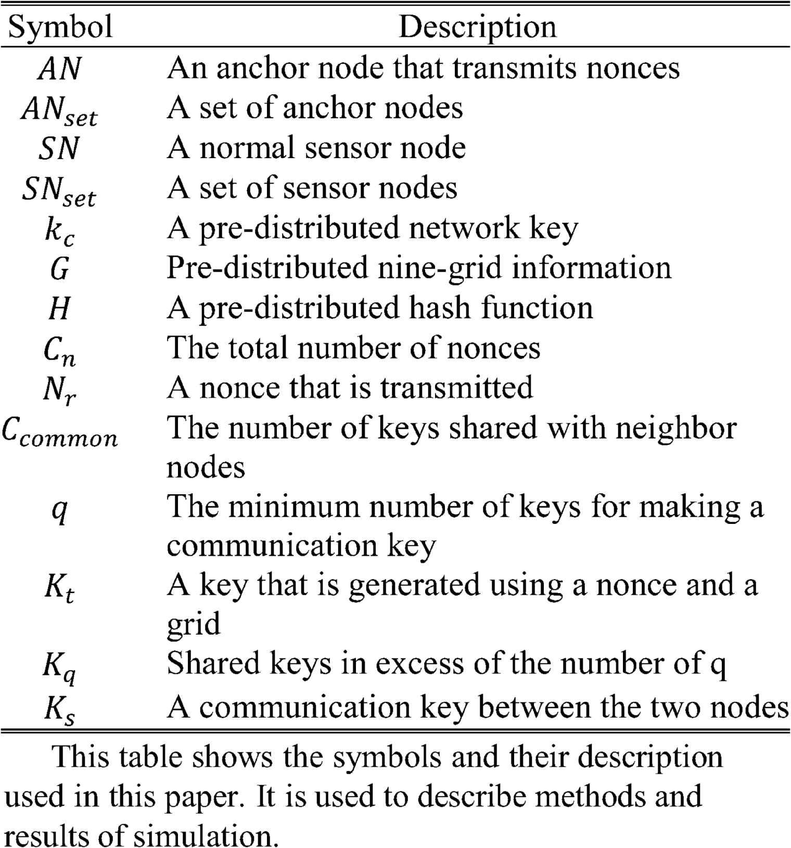

A. Notation

Table I lists the symbols used in this paper and their meanings.

B. Network Model

We propose a WSN model that is composed of a base station (BS), a cluster head (CH), anchor nodes (ANs), and SNs. An SN finds the neighbor node, senses and collects data, and sends them in a hop-by-hop form to a CH. An AN transmits different nonces to SNs according to a power level. The SN generates a pairwise key using the nonces received from the AN. In this paper, we only focus on the key management between SNs and do not consider the communication between CHs or between a CH and a BS. Fig. 1 shows the network model that we are assuming.

C. Threat Model

In this paper, we consider a variety of insider attacks and out-sider attacks. An insider attack is more critical than an outsider attack because it bypasses authentication and authorization and drops critical packets. Various types of insider attacks include modification, misrouting, eavesdropping, and packet drops. The packet drop attack is particularly difficult to detect. Packet drop attacks can also decrease network performance. Packet drop attacks consist of a blackhole attack, a grayhole attack, or an on–off attack. Because of the characteristics of grayhole and on–off attacks, they are more difficult to detect than blackhole attacks [7]. In this paper, one of our objectives is to provide security against packet drop attacks and other insider attacks.

D. Remarks on LDK

LDK is different from other key management schemes be-cause it is only dependent on the location of SNs, whereas in

Fig. 1. Network model. The network model that we assume consists of a BS, CHs, ANs, and SNs. The SN gathers data from around itself and sends the data to the CH through hop-by-hop. The CH collects the data received from SNs and transmits to the BS. The AN transmits nonces that SNs use to generate communication key with the SN.

other schemes, the SNs have to be located on a corresponding grid. This means that LDK is a location-based scheme that removes the restriction of the SN location.

In this paper, we propose a scheme that solves some of the problems that can occur in LDK [6]. The differences between the proposed scheme and LDK can be summarized as the reinforcement of an interference problem, a countermeasure to insider threats, and availability. Previous LDK methods have not considered communication interference. Wu et al. [8] reported that the packet reception ratio decreases by 40% in MicaZ motes. The packet loss influences the number of nonces transmitted from an AN. This correlates with the connectivity. Because this parameter can increase the security level, we take into account the condition where the minimum number of common keys is high. We also consider the condition where the minimum number of common keys is very low.

Although they are dangerous to WSN communications, most key management schemes do not deal with insider threats. Consequently, we focus on a countermeasure against insider threats in WSN key management.

- PROPOSED SCHEME

The proposed scheme presents the key establishment process using ANs based on LDK. We have named this scheme LDK+. LDK+ has two steps. First, SNs generate a communication key to manage keys, and then, the keys are updated to secure the network against insider threats. Fig. 2 shows an illustration of LDK+. We add a key revision phase from a neighbor node and provide the key establishment process using grid information. Similar to the original LDK, each SN saves a network key, a hash function, and the additional grid information, which is predistributed by a BS. The total number of grid data is 9, and these data consist of the coordinates of the arranged

This article has been accepted for inclusion in a future issue of this journal. Content is final as presented, with the exception of pagination.

CHOI et al.: LOCATION-BASED KEY MANAGEMENT STRONG AGAINST INSIDER THREATS IN WSNs | 3

Fig. 2. Illustration of LDK+. The SN pre-distributes grid information in a BS. After the SN is deployed in a field, the AN sends nonces at different power levels.
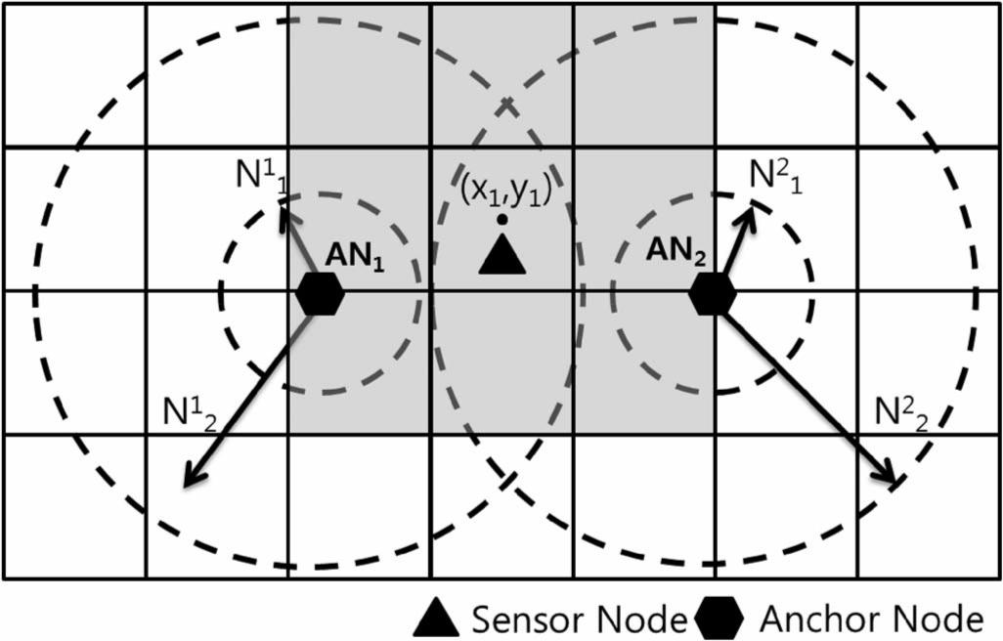

grid and eight neighbor grids. We also consider the situation where the SN does not deploy in the assigned grid position

- The key generation between SNs consists of four phases, i.e., predistribution, initialization, key establishment, and key agreement. In the following section, we describe the details of each phase.

A. Setup Protocol (Deployment)

To secure against various active attacks, there are four steps to establish a communication key in LDK+, i.e., the predis-tribution phase, the initialization phase, the key establishment phase, and the key agreement phase. In the following sections, each step will be explained in detail.

- Predistribution Phase: In the predistribution phase, SNs save the information that is needed to manage the key before a

deployment. The factors saved in SNs are described as follows: a network key K_{c} for secure communication before establishing a communication key K_{s}, a hash function H that is used to gen-erate a key, and the nine-grid information G_{i}(1 ≤ i ≤ 9). The following expression shows the algorithm at the predistribution phase:

(ACK) message as neighbor nodes. The following algorithm shows the method of creating a neighbor table:

SN_{o} → ∗SN_{l} : hello message

IF SN_{l} → SN_{o} : ACK

SN_{o} : add SN_{l} :∈ neighbor set

ELSE

IF counter threshold

- hello count of SN_{o}

delete SN_{l} ∈ neighbor set

ELSE

SN_{o} → SN_{l} : hello message

hello count of SN_{o}

= hello count of SN_{o} + 1. | (2)

- Initialization Phase: The initialization phase is a process by which an SN is transmitted from ANs. In this phase, the nonce revision is progressed. The AN transmits encrypted nonces to SNs at different power levels. After receiving nonces from ANs, the SN transmits the encrypted coordinates of the assigned grid to the neighbor nodes. The neighbor node, which has the same coordinates as the assigned grid, transmits the number of nonces to the SN. If the number of nonces transmit-ted by the other neighbor node is greater than its own number of nonces, the SN requests the nonces from that neighbor node to revise its own nonces. The following algorithm shows the initialization phase:

^{SN}set → ^{SN}set : ^{E}k_{c} ^{(N}uv ⁾
(1 ≤ u ≤ n, 1 ≤ v ≤ power level)

SN_{o} → SN_{l} : E_{kc} (G(x, y))

SN_{l} → SN_{o} : E_{kc} (C_{n})
IF C_{n} of SN_{o} < C_{n} of SN_{l}

SN_{o} → SN_{l} : request nonces

SN_{l} → SN_{o} : ACK(E_{kc} (N_{r}))(1 ≤ r ≤ C_{n} of SN_{l}). (3)

AN_{set} = AN₁, AN₂, . . . , AN_{n} |  | 3) Key Establishment Phase: In the key establishment phase,
SN_{set} = SN₁, SN₂, . . . , SN_{n} |  | an SN generates a key by combining nonces and the nine-grid
SN_{set} = SN₁, SN₂, . . . , SN_{n} |  | information and by using the hash function with a network key.
SN_{set} ← K_{c}, G, H. | (1) | Thus, each SN can generate keys that are nine times larger than
SN_{set} ← K_{c}, G, H. | (1) | the number of nonces. After that, the SN deletes the nonces.
The process of initiating blackhole attacks can be divided |  | The following algorithm shows the key establishment phase:
into three sequential stages. First, the attacker captures an SN |  | SN_{set} : K_{t} = H_{kc} (N_{r} G(x, y)). | (4)
and extracts critical information. Second, the attacker redeploys |  | SN_{set} : K_{t} = H_{kc} (N_{r} G(x, y)). | (4)
a compromised node to WSNs. Finally, the actual blackhole |  | 4) Key Agreement Phase: In the key agreement phase, the
attacks are launched. Hence, before the key is established, we |  | SN generates a communication key with its neighbor nodes.
consider preventing node capture as a potential countermeasure |  | The SN encrypts all the keys that it generated and attaches a
against blackhole attacks. Each SN generates its neighbor table |  | message authentication code (MAC) value to ensure integrity.
using a hello message, which is similar to the work presented |  | The neighbor node checks whether it has the same keys among
in [10]. An SN recognizes the nodes that send an acknowledge |  | its transmitted keys. If the number of the same keys is greater

This article has been accepted for inclusion in a future issue of this journal. Content is final as presented, with the exception of pagination.

4
Fig. 3. Data stream of a SN.
than a certain value, the SN generates the communication key by implementing an EXCLUSIVE-OR (XOR) operation with the same keys. The following algorithm shows the key agreement phase:

IEEE SYSTEMS JOURNAL

SN_{o} → ∗ : E_{kc} (k₁ k₂ · · · k_{t}) MAC IF the number of common keys > q
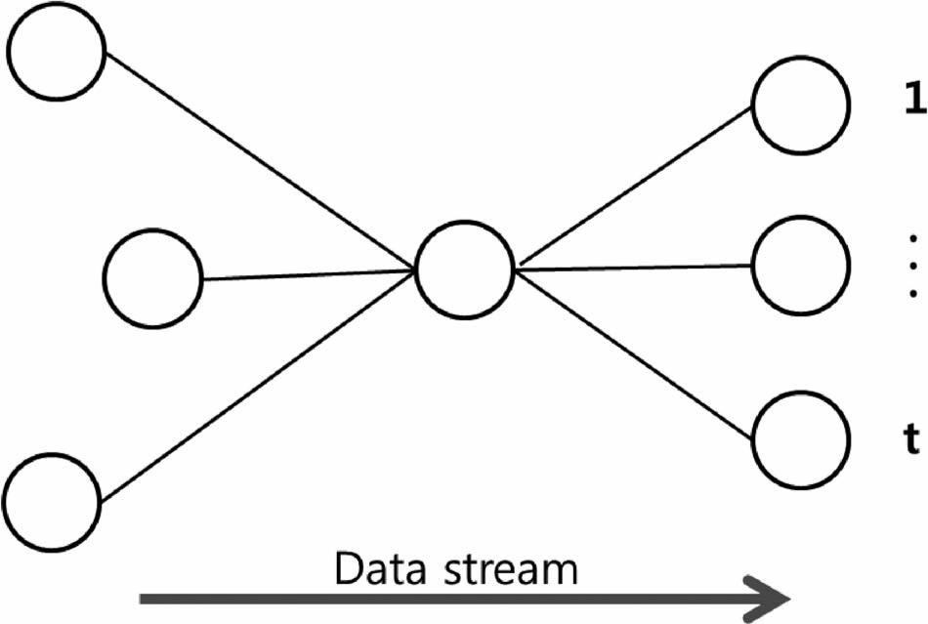
SN_{l} → SN_{o} : E_{kc} (k_{q}) MAC

SN_{o}, SN_{l} : K_{s} = k_{q} ⊕ · · ·
ELSE

SN_{l} → SN_{o} : none msg.

with all of its neighbor nodes. Therefore, the communication key is only maintained with maximum t neighbor nodes for the path determined by the routing protocol based on the work in [11], and the rest are deleted. Specifically, the considered path is from an SN to the neighbor nodes. According to a path route, each SN holds from 1 to a maximum of t neighbor nodes for the path that each SNs transmits and forwards. The neighbor node to which the SN first sends data is determined by the descending order of the routing path. This means that the data are transmitted in the form of a tree-form routing path.

In the proposed scheme, each SN performs two processes to resist an insider threat. An SN maintains a sequential number of data transmitted from the other SN when the SN transmits data in a hop-by-hop form. When authenticating the trans-mitted data, a sequence number renewal process of the source node data is performed. If the difference between the trans-mitted sequence number and the previous sequence number is larger than the threshold value, the node that transmitted the data is deleted from the neighbor table. Moreover, the SN checks a sequence number against a neighbor table, and when the number does not change for a certain time, it is deleted from the neighbor table. Afterward, a rekeying command packet is delivered to a BS to notify it that a key renewal process of the whole network is needed. Algorithm A1 shows the process. The BS transmits a rekeying message to all the ANs, and the ANs transmit new nonces to the SNs. After that, a new communication key is generated by sequentially implementing

- steps 3–5.

B. Update Protocol

Although the communication is encrypted, that precaution is meaningless if an insider threat occurs while the network is working. In this scheme, the key is reestablished to recover the network when a packet drop attack occurs. In the following sections, we explain the node addition process, rekeying, and the revocation process in detail.

- Node Addition: An add node is deployed after it is reg-istered. A BS transmits an authentication value of the node ID added to the CH. After sending a hello message to its neighbor nodes, the neighbor nodes require authentication from the CH. The authenticated nodes request nonces from neighbor nodes through the initialization phase and generate a communication key with neighbor nodes through the key generation phase. One limitation is that a network key must be securely manipulated during the whole phase of the update.

- Rekeying and Revocation: We need to consider the char-acteristics of a WSN. Each SN collects data for its own purpose and transmits to a BS. Because the data transmitted to a BS are composed of a CH, this paper only considers the hop-by-hop data transmission from an SN to a CH. After all the steps of key generation are performed, a routing path would be determined by a routing protocol. Fig. 3 shows that there are various routes for a node when forwarding data after the routing protocol is set. SNs can be forwarded from many other nodes, and the forwarding location can be changed according to the SNs that forward the data. The main point of key management in a static WSN is that an SN does not need to share a communication key

Algorithm A1: Rekeying Alarm

- Each received packet
- If τ > sequence number_{curr} − sequence number_{prev}
- remove the node

- alarm the BS

- Else

- processing packet

The SN that sends the data uses a hash function to generate the MAC of a sequence number. The SN that receives the data authenticates a transmitted sequence number to check if it has been modified by an attacker through MAC authentication.

An SN stores maximum t neighbor nodes to a neighbor table when it sends the data. Each SN computes costs according to each cycle λ and decides the next neighbor node that will send the data. First-in–first-out (FIFO) is used to compute costs such that the most recently linked neighbor node gets the lowest priority. The cycle that changes the neighbor node is differently computed according to each SN. The frequent changes in the neighbor node for the SNs that are deployed at an important location or close to the CH would decrease efficiency or interrupt the data flow. Therefore, the change of neighbor nodes depends on the importance of their location, and that importance is computed in proportion to the volume of data over time. When the SN changes its neighbor node, it sends a hello message to the neighbor node to check if it is alive. If the neighbor node does not return an ACK message, the SN deletes the information of the neighbor node and repeats the

This article has been accepted for inclusion in a future issue of this journal. Content is final as presented, with the exception of pagination.

CHOI et al.: LOCATION-BASED KEY MANAGEMENT STRONG AGAINST INSIDER THREATS IN WSNs | 5

Fig. 4. Hexagonal deployment.
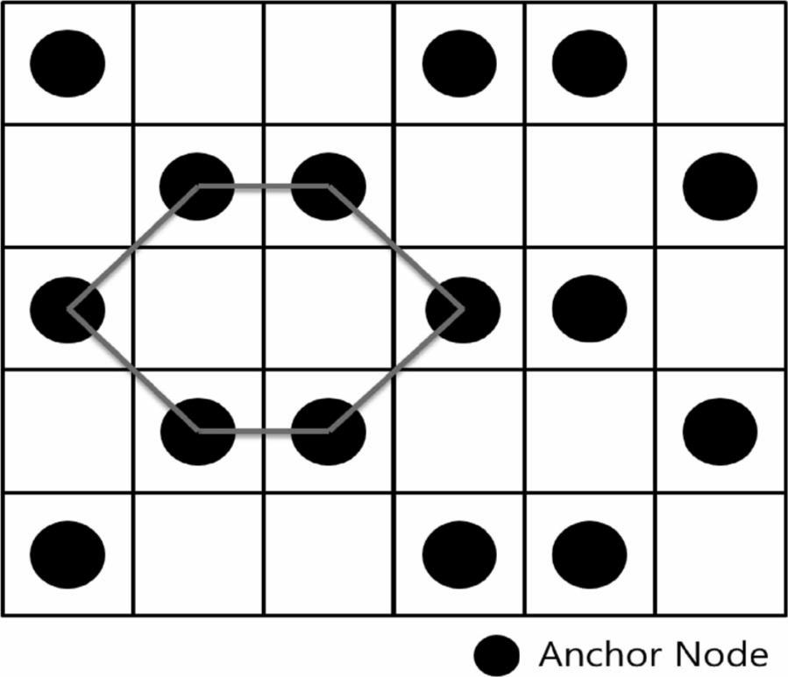

same process with the next neighbor node. Algorithm A2 shows the processes.

Algorithm A2: Changing the Neighbor Node

  - FIFO (a list of neighbor nodes)

  - At each interval of λ

  - If next neighbor node == alive

  - change the next hop

  - Else

  - remove the next neighbor node

  - find the next hop.

C. Alternative Hexagonal Deployment

In addition, we present an alternative method to deploy ANs more efficiently. Research into the hexagonal grouping form has been conducted continuously [12]. In this paper, a hexag-onal deployment of ANs is researched for reducing network costs. Fig. 4 shows the hexagonal deployment in a network. When ANs are deployed in a hexagonal form over 20 × 20 grids, 200 ANs can be deployed. In comparison to deploying one AN per grid, the number of ANs can be reduced by one half. If the hexagonal deployment provides good connectivity and suitable security without any additional process, network costs can be reduced. We describe the applicability of the hexagonal deployment in Section V.

IV. SECURITY ANALYSIS

So far, we have considered how to resist threats in the key management perspective of WSNs. In this section, we organize the attack scenario into outsider attacks and insider attacks according to the direction of the attack, and we present how to defend against various attack scenarios.

A. Outsider Attacks

In the following, we give examples of some typical outsider attacks on WSNs and demonstrate how our proposed scheme can prevent them.

  - Eavesdropping: WSNs are very easy to eavesdrop be-cause they are wireless and an attacker can eavesdrop any-where. The proposed scheme uses a pairwise key among SNs. This means that the SNs use different keys for each path for secure communication. Although the attacker eavesdrops on the message, it cannot get meaningful data because the data are encrypted.

  - Node Capture Attack: In contrast to other networks, an SN in WSNs can lose control to an adversary because of hardware restrictions. Therefore, node capture attacks are more harmful because they will not only damage SNs but also cause secondary damage in the form of key information leakage. In this paper, when a node capture attack transpires, the key update of the whole network will occur because packets are dropped. An AN transmits nonces, which are encrypted with a predistributed network key. When an attacker deploys a compromised node in the network, a communication key can be generated because it can receive nonces. However, the ID of the compromised node is deleted from a BS, and the BS broadcasts the excluded ID to the SNs. Therefore, the SNs can delete the compromised node from the neighbor table. However, this method is not perfectly secure because the secondary method of a node capture attack would be more intelligent.

  - Replay Attack: An attacker continuously sends captured data to SNs, forcing the SNs to waste resources and possi-bly increasing traffic. However, the proposed scheme adds a sequence number and its MAC value to the transmitted data. The SNs manage the sequence numbers of the data received from neighbor nodes, and the received data and changes in the sequence number are distinct because of their MAC values. Therefore, we can minimize the damage of a replay attack.

- Insider Attacks

We also give examples of some typical insider attacks on WSNs and demonstrate how our proposed scheme can prevent them. In particular, we focus on certain circumstances in which packet drop attacks occur.

- Blackhole Attack: In the proposed scheme, SNs period-ically change neighbor nodes according to a cost value. A blackhole attack is when a node drops all of its packets. When the attack occurs, each SN periodically changes neighbor nodes using cycle information and a cost value. If the next node drops all the packets, it cannot send an ACK message in response to the corresponding hello message. With the proposed scheme, the node will check the next node. When a blackhole attack occurs, our scheme proposes a method of self-organization to minimize the damage in the WSN key management.

- Grayhole and On–Off Packet Drop Attacks: The proposed scheme is resistant to on–off packet drop attacks and grayhole attacks. A user can stymie such attacks by changing neighbor nodes periodically. However, because the packets are dropped randomly or periodically, the possibility that a compromised node could still pass an alive test exists. Therefore, the scheme probabilistically resists on–off packet drops and grayhole at-tacks. The attacks can be blocked using a key update method with the sequence number. When packets are dropped, there is a difference in sequence numbers. Because SNs manage the

This article has been accepted for inclusion in a future issue of this journal. Content is final as presented, with the exception of pagination.

6
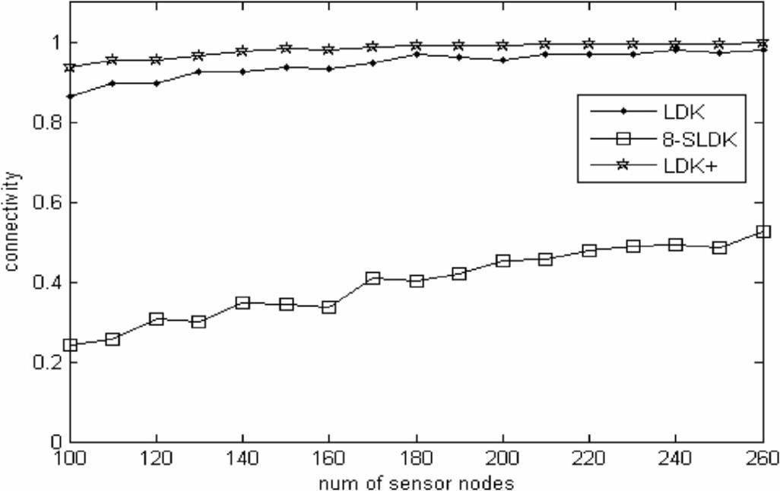

Fig. 5. Connectivity. Comparing the connectivity of LDK+ with that of other schemes. Connectivity is shown according to the number of SNs.

sequence number of neighbor nodes in the form of a table, they can recognize the attack by comparing the sequence number when they receive the transmitted data after the packet drop. When the attack occurs, they request a key update from a BS. The damaged nodes are excluded from the next key renewal. Therefore, WSNs can be secured against these attacks by using the sequence number method.

- SIMULATION AND COMPARISON

In this section, we compare the proposed scheme with exist-ing schemes and simulate connectivity and compromise ratios using C++ and MATLAB.

A. Connectivity

We first divide the installed area into 20 × 20 grids, place one AN per grid to assume an environment with 400 ANs, and measure the connectivity of LDK, 8-sectorized LDK (SLDK) [13], and LDK+. The numerical value is the average of ten simulation results in the same environment. When C_{common} is low, these schemes have similar connectivity. In the assumed environment, we divide the power level of an AN into two parts and set the transmission range of the AN as one unit and the transmission range of an SN as two units. C_{common} is configured as 6. Fig. 5 shows the simulation results of the connectivity of each scheme. The connectivity of LDK+ is higher than that of LDK, and the connectivity of both increases as the value of the SN increases.

Fig. 6 shows the connectivity of each scheme according to C_{common}. We consider an environment where 150 SNs, whose transmission range is three units, are deployed randomly. In this case, as C_{common} increases, the connectivity of LDK+ stays as it is, whereas the connectivity of LDK decreases. Generally, the connectivity of 8-SLDK, which is divided into eight sectors, is low.

In addition, we simulate several conditions in various en-vironments. We assume that 100 SNs are deployed and that C_{common} is 1. The connectivity of LDK+ is then 0.937 when the transmission range of SNs is two units. The connectivity of LDK+ is 1 when the transmission range of SNs is three units. Eventually, if there are neighbor nodes within the transmit

IEEE SYSTEMS JOURNAL
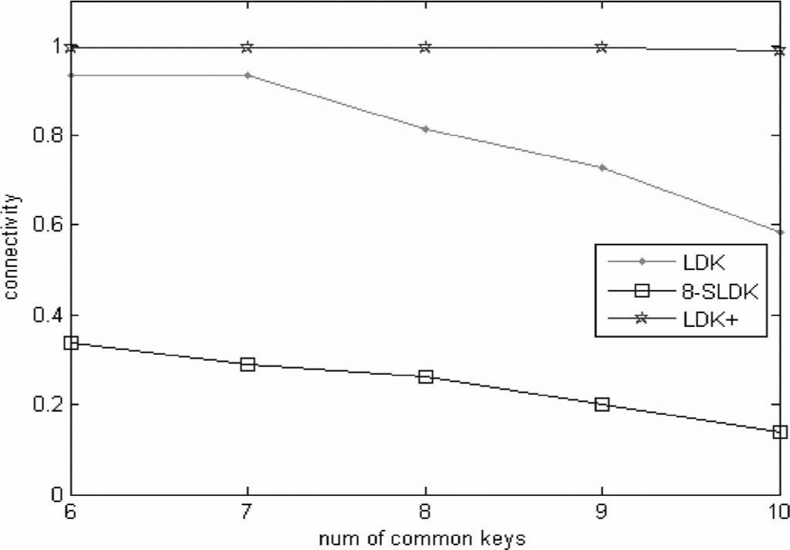

Fig. 6. Connectivity. Comparing the connectivity of LDK+ with other schemes. Connectivity according to the number of common keys.

range of each SN, all of the SNs can communicate with each other. If the SNs are spread out ideally, the connectivity of the SNs will be 1.

The connectivity can be changed according to the number of nonces it gets from an AN and C_{common}, which affects security. In the assumed environment, each SN receives 14 nonces from ANs on average. Under this condition, the con-nectivity decreases as C_{common} increases. The connectivity of LDK rapidly drops when C_{common} is 6, and the connectivity of LDK+ rapidly drops when C_{common} is 19. Therefore, it is considered that the highest security is obtained when C_{common} is 18 in LDK+. The number of ANs is related to the sensor network costs.

If the connectivity can be maintained as the number of ANs decreases, network generating costs can be saved. To reduce the number of ANs, we apply a hexagonal deployment. When deploying in a hexagonal shape, we can form a network with only 200 ANs, whereas 400 ANs were needed before. When we set the transmit range as 1.6 units and keep the other conditions the same, the connectivity of 100 SNs is almost the same as the previous value. Figs. 7 and 8 show the result of a simulation that compares the connectivity according to the deployments. We can see in the simulation that similar connectivity can be maintained, whereas the number of ANs decreases when nodes are in a hexagonal shape.

B. Compromise Ratio

For the simulation of the compromise ratio, we refer to [14, eq. (6)] as follows:

 |  | | | s | | |  | |s|−i |  |  |  |  | 2(m−i)
p(i) = |  | | | i | | |  | 2(m−i) |  |  |  |  | m−i
 |  |  |  |  |  |  | s |  |  | 2
 |  |  |  |  |  |  | |_{m}| |  |  | m |  |  |  |  |  |  |  |  |  |  | m |  |  |  | x |  |  |  | ^{i} p(i)
 |  |  |  |  |  |  |  |  | × |  |  |  | 1 − |  |  |  |  | 1 − |  |  |  |  |  |  |  |  |  |  |  |  |  | . (6)
 |  |  |  |  |  |  |  |  |  |  |  |  |  |  |  |  |  |  |  | s |  | | |  |  |  |  |  |  |  | p
 |  |  |  |  |  |  |  |  |  | _{i} |  |  |  |  |  |  |  |  |  |  | |
 |  |  |  |  |  |  |  |  |  | =q

The size of the key pool is s. The number of captured nodes is x. The size of the key ring is m. The minimum number of

This article has been accepted for inclusion in a future issue of this journal. Content is final as presented, with the exception of pagination.

CHOI et al.: LOCATION-BASED KEY MANAGEMENT STRONG AGAINST INSIDER THREATS IN WSNs | 7
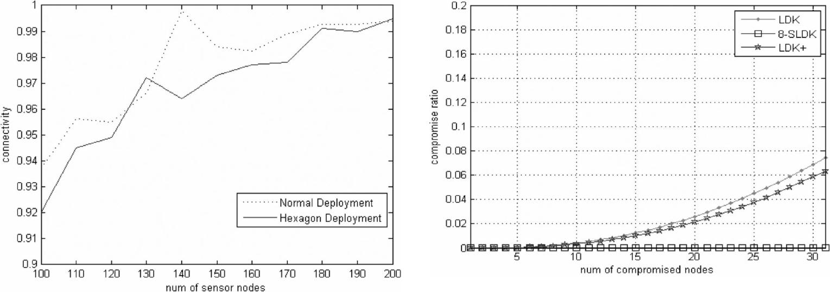

Fig. 7. Connectivity. Comparing the connectivity of LDK+ according to deployments. Connectivity is shown according to the number of SNs.
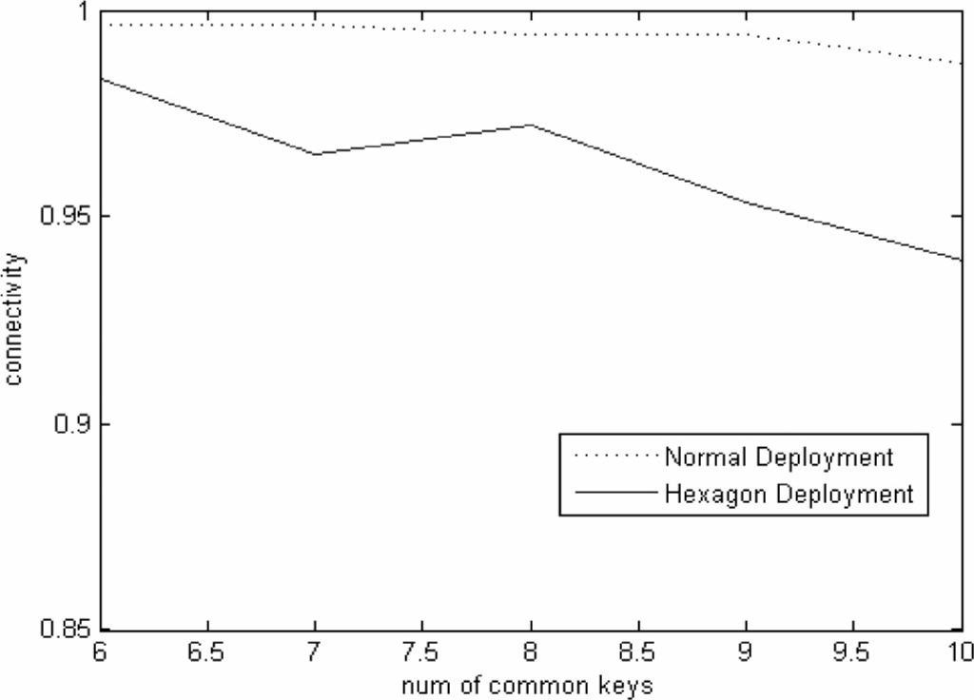

Fig. 9. Compromise ratio. Comparison of the compromise ratio of LDK+ with that of other schemes. Connectivity is shown according to the number of SNs.
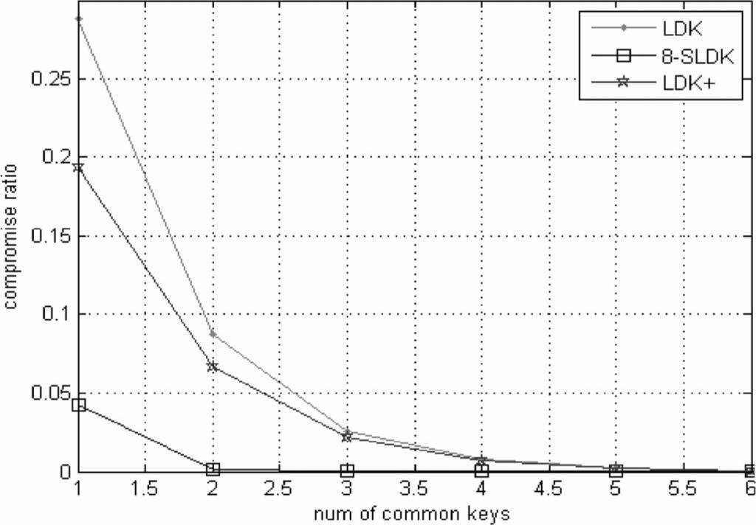

Fig. 8. Connectivity. Comparing the connectivity of LDK+ according to deployments. Connectivity is shown according to the number of SNs.

Fig. 10. Compromise ratio. Comparison of the compromise ratio of LDK+ with that of other schemes. Connectivity is shown according to the number of common keys.

shared keys is q. p(i) is the probability that any two nodes have

- keys in common.

Figs. 9 and 10 show the results of the simulation. The size of m is configured as 7 in LDK and 8-SLDK. The maximum of LDK+ is set as 63. This is because LDK+ generates keys by combining nonces and the nine-grid information. When C_{common} is 6, the total compromise ratio is lower than 0.08 according to the number of captured nodes. The compromise ratio of LDK+ is lower than that of LDK, but it is higher than that of 8-SLDK. However, LDK+ is considerably more feasible than 8-SLDK because LDK+ has higher connectivity than 8-SLDK when C_{common} is 6. The compromise ratio increases as the number of common keys increases. This result implies that an increase in the number of common keys improves security.

In conclusion, the connectivity of LDK+ is high when the minimum number of common keys required for key establish-ment is high. The compromise ratio of LDK+ is lower than that of LDK, but it is higher than that of 8-SLDK. We also confirm that the absolute value of the compromise ratio is low.

C. Comparison

The existing key management schemes using a grid for WSNs [15]–[17] utilize a grid as a key ring or an identifier, which uniquely identifies an SN. One of the conditions among the schemes is that an SN should be deployed in an assigned grid. On the other hand, there is no deployment condition in the Anjum scheme [6]. However, LDK is simulated to generate a communication key in a low C_{common} environment. C_{common} is an important variable in network security. C_{common} for generating the communication key relates to the security in WSNs. When a node is captured, a secure link is likely to be broken if C_{common} is low because the communication key is derived from a few common keys. Thus, we only consider the condition when C_{common} is high.

D. Recovery Rate

In this paper, we can distinguish nodes in a packet drop attack by managing the sequence number of the received data to defend against any kind of drop attacks. After the rekeying process, the SNs damaged by a packet drop attack are included

This article has been accepted for inclusion in a future issue of this journal. Content is final as presented, with the exception of pagination.

8 IEEE SYSTEMS JOURNAL

Fig. 11. Packet drop attack in complete binary tree. When an insider attacker drops packets in a complete binary tree structure of route path, a proportion of the SNs get damaged.
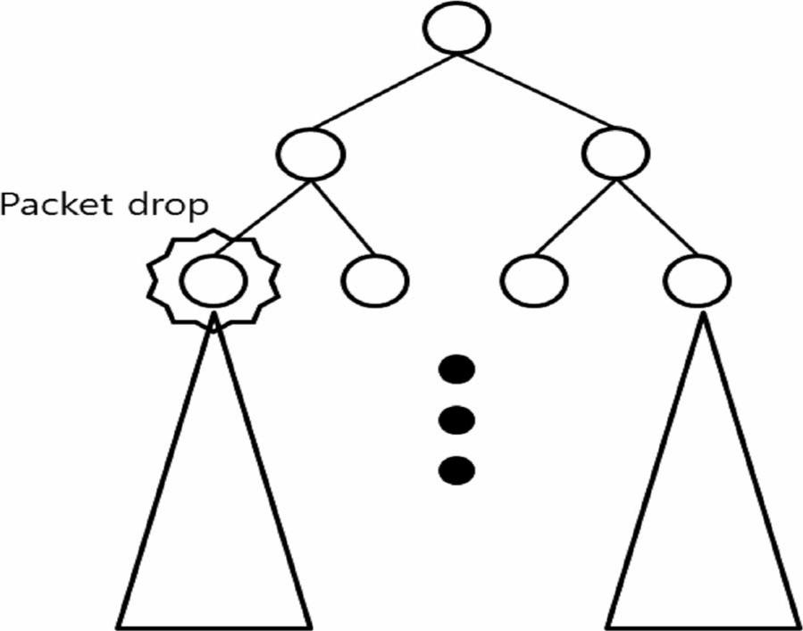

in a network. When a packet drop attack strikes a network that does not consider insider attacks, all the packets that are forwarded through the SNs will be dropped, and the network will lose its function. For example, if the routing path structure of SNs is a complete binary tree structure, we can compute the number of malfunctioning SNs. Fig. 11 shows the circumstance in which a packet drop attack occurs. In a complete binary tree composed of L level nodes, when M -level SNs are attacked, the
number of damaged SNs is ^{L−M−1} 2^{i}. In an unrecoverable
i=0
network, only 1 − ^{L−M−1} 2^{i}/N of SNs still operate; in the
i=0
proposed scheme, however, the nodes are recoverable except for the attacked node, which means that N − (1/N ) of SNs still operate.

VI. RELATED WORK

- Random Key Predistribution: The most researched part of key management in WSNs is random key predistribution. Eschenauer and Gligor [5] extracted a certain size of key rings from a large key pool in a server, and they distribute key rings before SNs are deployed. The deployed SNs use a commonly stored key in the key rings of two nodes to generate a pairwise key for secure communication with the neighbor nodes. Based on this scheme, Chan et al. [14] proposed the q-composite key management scheme that only generates a key when two SNs share at least q keys. This scheme provides resilience when SNs are compromised. Du et al. [18] have applied Blom’s scheme to key management in WSNs. This is called the λ-secure random key predistribution scheme, and it gives perfect security when fewer than λ SNs are compromised.

Many recent WSN key management studies proposed a hierarchical architecture for networks, which are composed of a BS, a CH, and SNs [19]–[21]. This is because SNs make it hard to apply a high computational cryptographic method due to inadequate hardware performance. Instead, they applied cryptographic methods to CHs that have greater hardware performance than an SN. Moreover, to resist various types of attacks, researchers applied a time stamp to authenticate packets [22] and provided key revocation through the periodic authentication of SNs [23].

- Location-Based Key Predistribution: Most methods of location-based key management for WSNs use grid informa-tion. The grid information includes the coordinate after an area is divided into grids. The precondition that an SN is deployed in an assigned grid is essential. This condition can be a constraint according to deployed areas.

Huang et al. [15] proposed a grid-group scheme that uses known deployment information. Instead of randomly distribut-ing keys from a large key pool to each sensor, secret keys for each sensor are systematically distributed from a structured key pool. This scheme applies an identifier by combining the grid information and an ID for each SN, and it predistributes both an identifier and Blom’s scheme to the SNs. Ito et al. [16] proposed a scheme wherein keys are mapped to 2-D positions, and the positions are estimated using a node probability density function to decide the keys that are distributed to a node. An SN randomly requests an assigned key from other SNs within the transmission range. Du et al. [17] proposed a scheme that assigns a subkey set extracted from a key pool in a grid. This scheme uses nonuniform probability density functions that suggest that a sensor is likely to be deployed in certain areas. Liu et al. [24] utilized a grid coordinate of an SN when generating a pairwise key using a bivariate key polynomial. Kwon et al. proposed the full and random pairwise key protocol [9].

In 2006, Anjum [6], [25] proposed a scheme called LDK that generates a key by combining a predistributed key ring with nonces. In 2010, Anjum extended the scheme. In contrast to schemes that are dependent on the position of grids, LDK is dependent on the position of SNs. Using a feature of the AN that transmits data within a certain distance by adjusting its power level, an area is divided. An SN is distributed to an area after storing a single common key K and hash function H. ANs transmit each nonce at a different power level, and an SN generates single keys as follows: k_{j}^{i} = H_{k}(n^{i}_{j} ). When an SN finds common keys whose number is larger than a certain

number of keys with a neighbor node, a communication key is derived as k = H(k₁, k₂, . . . , k_{q} ). Faghani and Motahari [13] proposed SLDK in 2009. This reinforces the key resiliency of LDK by adding a scheme that divides the transmission range of an AN into n sectors.

VII. CONCLUSION

In this paper, we have presented LDK+, which is an im-proved version of the LDK scheme of Anjum [6]. We added key revisions by incorporating the use of grid information into the previous dividing method, and we suggest key generation by combining the grid information. Thus, we solve the problem of insufficient numbers of nonces that can occur under the condition of communication interference. We also consider key establishment and key revocation, as well as packet drop attack among other insider attacks.

Through this simulation, we confirm that LDK+ has higher connectivity and a lower compromise ratio than LDK, which means that stability and security are improved. Moreover, through the hexagonal deployment of an AN arrangement, we show that network costs can be reduced without compromising the connectivity by decreasing the number of ANs.

This article has been accepted for inclusion in a future issue of this journal. Content is final as presented, with the exception of pagination.

CHOI et al.: LOCATION-BASED KEY MANAGEMENT STRONG AGAINST INSIDER THREATS IN WSNs | 9

REFERENCES

- W. Jia, H. Zhu, Z. Cao, X. Dong, and C. Xiao, “Human-factor-aware privacy-preserving aggregation in smart grid,” IEEE Syst. J., vol. 8, no. 2, pp. 598–607, Jun. 2014.

- T. Kwon and J. Hong, “Secure and efficient broadcast authentication in wireless sensor networks,” IEEE Trans. Comput., vol. 59, no. 8,
  - 1120–1133, Aug. 2010.

- L. D. Xu, W. He, and S. Li, “Internet of things in industries: A survey,” IEEE Trans. Ind. Inform., vol. 10, no. 4, pp. 2233–2243, Nov. 2014.

- C. Fan, S. Huang, and Y. Lai, “Privacy enhanced data aggregation scheme against internal attackers in smart grid,” IEEE Trans. Ind. Inform., vol. 10, no. 1, pp. 666–675, Feb. 2014.

- L. Eschenauer and V. D. Gligor, “A key-management scheme for dis-tributed sensor networks,” in Proc. 9th ACM Conf. Comput. Commun. Security, 2002, pp. 41–47.

- F. Anjum, “Location dependent key management in sensor networks without using deployment knowledge,” Wireless Netw., vol. 16, no. 6,
  - 1587–1600, Aug. 2010.

- Y. Cho, G. Qu, and Y. Wu, “Insider threats against trust mechanism with watchdog and defending approaches in wireless sensor networks,” in Proc. IEEE Symp. SPW, 2012, pp. 134–141.

- Y. Wu, J. A. Stankovic, T. He, and S. Lin, “Realistic and efficient multi-channel communications in wireless sensor networks,” in Proc. IEEE 27th Conf. Comput. Commun. INFOCOM, 2008, pp. 1867–1875.

- T. Kwon, J. Lee, and J. Song. “Location-based pairwise key predistri-bution for wireless sensor networks,” IEEE Trans. Wireless Commun., vol. 8, no. 11, pp. 5436–5442, Nov. 2009.

- W. Ding, Y. Yu, and S. Yenduri, “Distributed first stage detection for node capture,” in Proc. IEEE GC Wkshps, 2010, pp. 1566–1570.

- C. E. Perkins and E. M. Royer, “Ad-hoc on-demand distance vector routing,” in Proc. IEEE WMCSA, 1999, pp. 90–100.

- X. Ma, Z. Dong, and J. Li, “A novel key management scheme for wireless sensor networks,” in Proc. IEEE 6th ICICSE, 2012, pp. 526–529.
- M. R. Faghani and S. A. Motahari, “Sectorized location dependent key management,” in Proc. IEEE WIMOB, 2009, pp. 388–393.

- H. Chan, A. Perrig, and D. Song, “Random key predistribution schemes for sensor networks,” in Proc. IEEE Symp. Security Privacy, 2003,
  - 197–213.

- D. Huang, M. Mehta, D. Medhi, and L. Harn, “Location-aware key management scheme for wireless sensor networks,” in Proc. 2nd ACM Workshop Security ad hoc Sens. Netw., 2004, pp. 29–42.

- T. Ito, H. Ohta, N. Matsuda, and T. Yoneda,“A key pre-distribution scheme for secure sensor networks using probability density function of node deployment,” in Proc. 3rd ACM Workshop Security Ad Hoc Sens. Netw., 2005, pp. 69–75.

- W. Du, J. Deng, Y. S. Han, and P. K. Varshney, “A key management scheme for wireless sensor networks using deployment knowledge,” Proc. 23rd Annu. Joint Conf. IEEE Comput. Commun. Soc. INFOCOM, 2004, vol. 1, pp. 1–12.

- W. Du, J. Deng, Y. S. Han, and P. K. Varshney, “A pairwise key pre-distribution scheme for wireless sensor networks,” ACM Trans. Inf. Syst. Security (TISSEC), vol. 8, no. 2, pp. 228–258, 2005.

- G. Han, R. Zhou, and H. Yang, “A SPT-Routing key management scheme for heterogeneous wireless sensor networks based on ECC,” in Proc. IEEE URKE, 2011, vol. 1, pp. 243–247.

- R. Zhou and H. Yang. “A hybrid key management scheme for Heteroge-neous wireless sensor networks based on ECC and trivariate symmetric polynomial,” in Proc. IEEE URKE, 2011, pp. 251–255.

- C. Ma, J. Wang, P. Wu, and H. Zhang, “Identity authentication and key agreement integrated key management protocol for heterogeneous sensor networks,” J. Comput., vol. 7, no. 8, pp. 1847–1852, Aug. 2012.

- M. Boujelben, H. Youssef, R. Mzid, and M. Abid, “IKM—An identity based key management scheme for heterogeneous sensor networks,” J. Commun., vol. 6, no. 2, pp. 185–197, Apr. 2011.

- M. R. Alagheband and M. R. Aref, “Dynamic and secure key management model for hierarchical heterogeneous sensor networks,” Inf. Security, IET, vol. 6, no. 4, pp. 271–280, Dec. 2012.

- D. Liu, P. Ning, and R. Li, “Establishing pairwise keys in distributed sensor networks,” ACM Trans. Inf. Syst. Security (TISSEC), vol. 8, no. 1, pp. 41–77, 2005.

- F. Anjum, “Location dependent key management using random key-predistribution in sensor networks,” in Proc. 5th ACM Workshop Wireless Security, 2006, pp. 21–30.

- Gartner, 2014. [Online]. Available: http://www.gartner.com/newsroom/id/ 2684915

Jaewoo Choi received the B.S. degree in game engi-neering from Korea Polytechnic University, Siheung, Korea, in 2014. He is currently working toward the M.S. degree at the Graduate School of Information, Yonsei University, Seoul, Korea.

His current research interests include computer network security and information security and privacy.

Jihyun Bang received the B.S. degree in mathemat-ics and professional English from Ewha Womans University, Seoul, Korea, in 2014. She is currently working toward the M.S. degree at the Graduate School of Information, Yonsei University, Seoul, Korea.

Her current research interests include crypto-graphic protocols, computer network security, and smart card security.

LeeHyung Kim received the B.S. and M.S. degrees in computer engineering from Kwangwoon Univer-sity, Seoul, Korea, in 1994 and 1996, respectively.

He is currently a Senior Researcher with the Agency for Defense Development, Seoul, Korea. He has been involved in projects for developing surveil-lance and reconnaissance sensor networks as a Par-ticipating Researcher. His current research interests include sensor signal processing, mission planning systems, power optimization, network protocols, and cyber warfare simulation.

Mirim Ahn received the B.S. degree from George Mason University, Fairfax, VA, USA, in 1985 and the M.S. degree from Korea University, Seoul, Korea, in 1994, both in computer science.

She is currently a Principal Researcher with the Agency for Defense Development, Seoul, Korea. Since 1986, she has been involved in many projects, including the development of military conscription and mobilization systems, military satellite systems, surveillance, and reconnaissance sensor networks, as a Participating Researcher and as a Project Manager.

Her current research interests include information security and privacy, network protocols, computer networks, and cyber warfare simulation.

Taekyoung Kwon (M’02) received the B.S., M.S., and Ph.D. degrees in computer science from Yonsei University, Seoul, Korea, in 1992, 1995, and 1999, respectively.

He is currently an Associate Professor of infor-mation with Yonsei University, Seoul, Korea. From 1999 to 2000, he was a Postdoctoral Research Fellow with the University of California, Berkeley, CA, USA. From 2001 to 2013, he was a Professor of computer engineering with Sejong University, Seoul, Korea. From 2007 to 2008, he was on sabbatical with

the University of Maryland, College Park, MD, USA. In 2013, he returned to Yonsei University, Seoul, Korea. His current research interests include information security and privacy, applied cryptography, network protocols, usable security, and human-computer interactions.

